BLINKIT GROCERY SALES ANALYSIS
Power BI Project Report
Business Intelligence & Data Analysis Project

Project | BlinkIT Grocery Sales Analysis
Primary Tool | Microsoft Power BI
Supporting Tool | Microsoft Excel
Prepared By | Aditya Verma

1. Project Overview
This project analyzes BlinkIT grocery sales data in Microsoft Power BI. The report is designed as an interactive business dashboard for evaluating sales performance across product characteristics, outlet characteristics, and outlet locations.
The accompanying PBIX file contains a single report page sized 1920 × 1080 and uses the BlinkIT Grocery Data table as the primary data source. The report contains KPI cards, charts, a matrix, and slicers for interactive analysis.

2. Tools Used
- Microsoft Power BI Desktop – dashboard development and interactive visualization
- DAX measures – KPI and analytical calculations used by the report
- Microsoft Excel – source dataset

3. Dataset
The supplied Excel dataset contains 8,523 records and 13 fields. The fields include item attributes, outlet attributes, visibility, weight, sales, and customer rating.
Fields: Item Fat Content, Item Identifier, Item Type, Outlet Establishment Year, Outlet Identifier, Outlet Location Type, Outlet Size, Outlet Type, Item Visibility, Item Weight, Sales, Rating, Fat Content Normalized

4. KPI Summary
The PBIX contains four KPI measures: Total Sales, Average Rating, Average Sales, and No Of Items.
Total Sales | Average Sales | No. of Items | Average Rating
1,201,681.49 | 140.99 | 8,523 | 3.97

The KPI values above are calculated directly from the supplied Excel source for this report. They provide a reference point for the dashboard's headline metrics.

5. Dashboard Components
Component | Purpose / Fields
KPI Cards | Total Sales, Average Rating, Average Sales, No Of Items
Donut Chart | Total Sales by Outlet Size
Line Chart | Total Sales by Outlet Establishment Year
Bar Chart | Total Sales by Item Type, with a Metrics field parameter
Funnel Chart | Sales by Outlet Location Type
Clustered Bar Chart | Sales by Outlet Location Type segmented by Item Fat Content
Donut Chart | Sales by Item Fat Content, with a Metrics field parameter
Matrix | Average Sales, Total Sales, No Of Items and Average Rating by Outlet Type
Slicers | Item Type, Metrics, Outlet Size, Outlet Location Type

6. Visual Analysis
Important: The charts in this section are recreated from the supplied Excel data for documentation purposes. They are not screenshots or exports of the Power BI canvas. The PBIX file in the repository is the authoritative interactive dashboard.
The following visuals are recreated from the supplied source dataset to document the analytical content represented in the PBIX. They are documentation visuals rather than exported screenshots of the Power BI canvas; the interactive Power BI experience remains in the accompanying .pbix file.

Total Sales by Fat Content
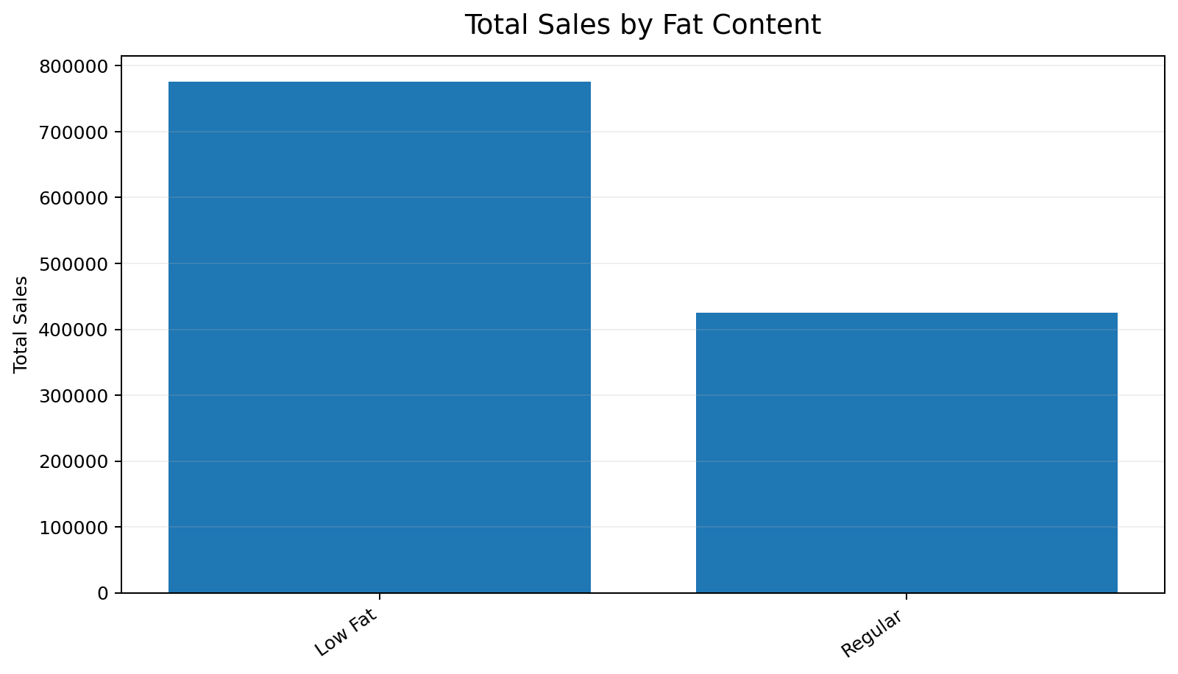
Shows sales after normalizing the source values into two reporting groups: Low Fat (including LF/low fat) and Regular (including reg). This normalization is used only for this documentation chart and is explicitly different from displaying the raw source labels.

Total Sales by Item Type
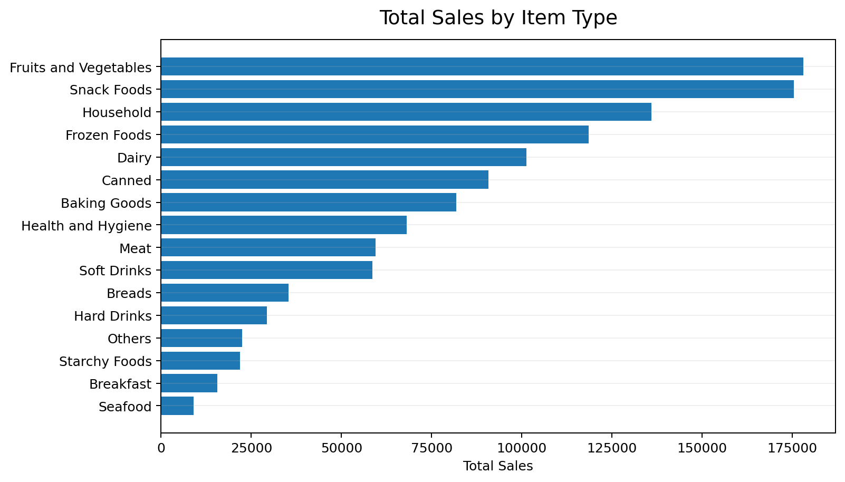
Compares sales contribution across the different grocery item categories.

Total Sales by Outlet Location Type
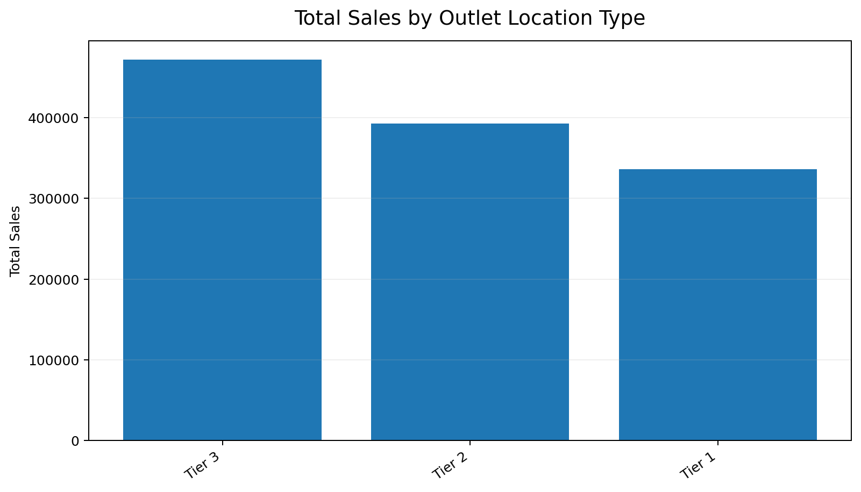
Compares sales across Tier 1, Tier 2, and Tier 3 outlet locations.

Total Sales by Outlet Size
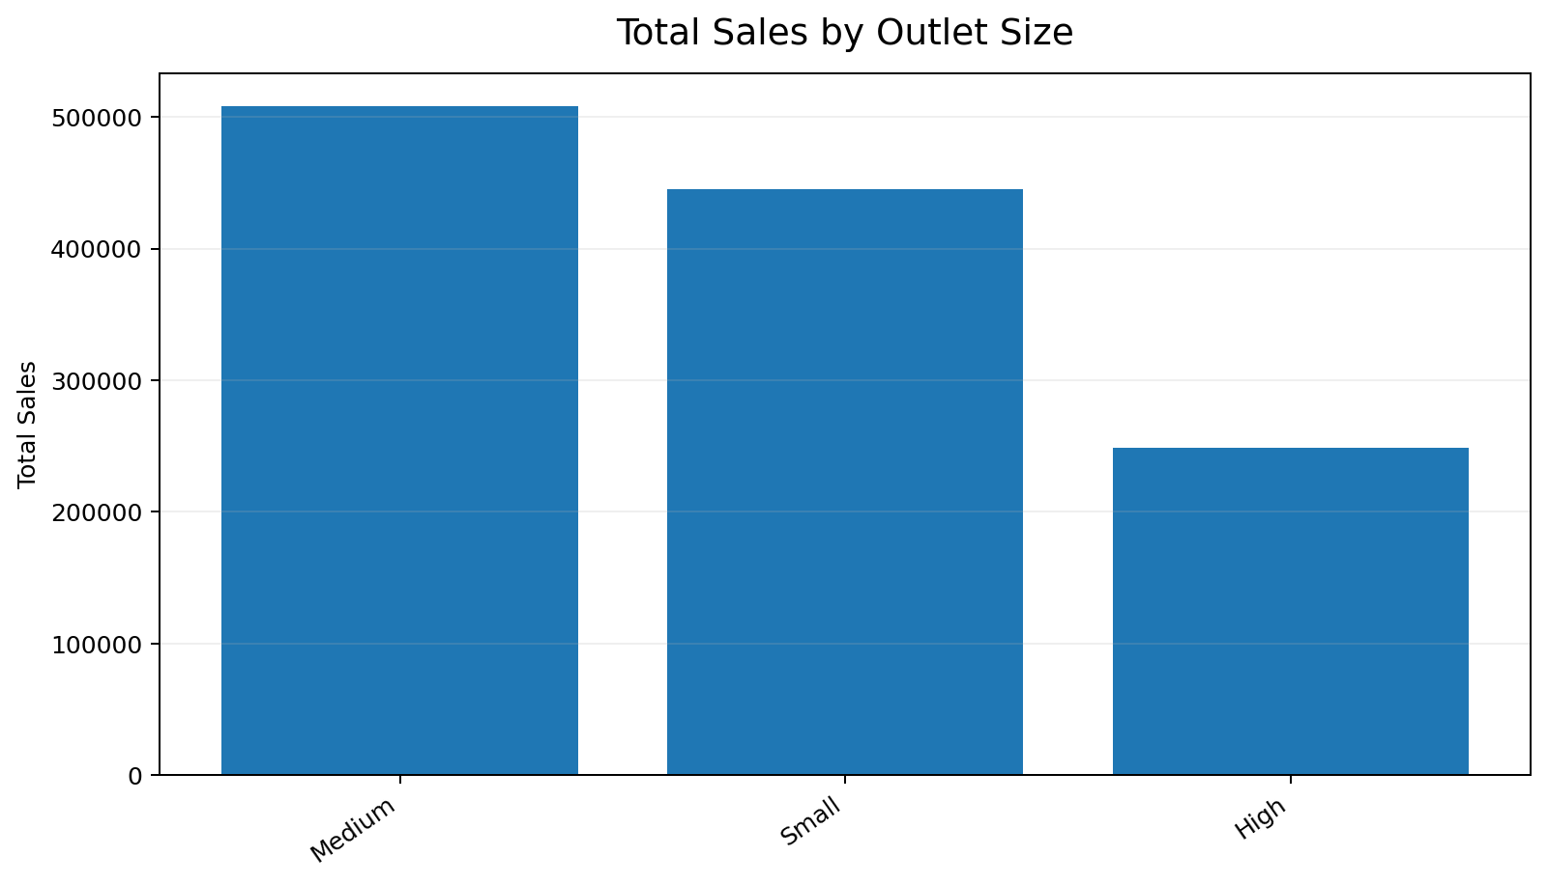
Compares total sales across Small, Medium, and High outlet sizes.

7. Additional Trend and Segmentation Analysis

Sales by Outlet Establishment Year
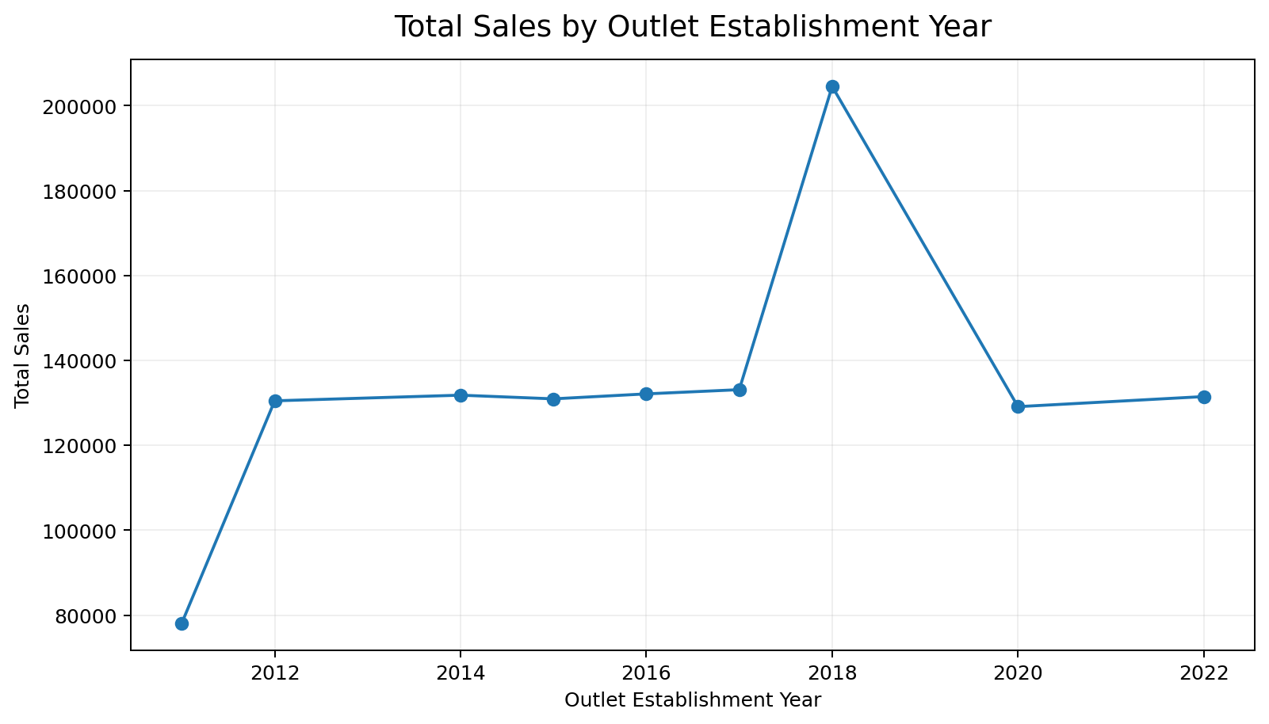
Shows total sales by outlet establishment year in chronological order. This documentation chart is intended to make the time trend easy to read; the interactive PBIX visual remains the source of truth for the dashboard.

Sales by Fat Content and Outlet Location Type
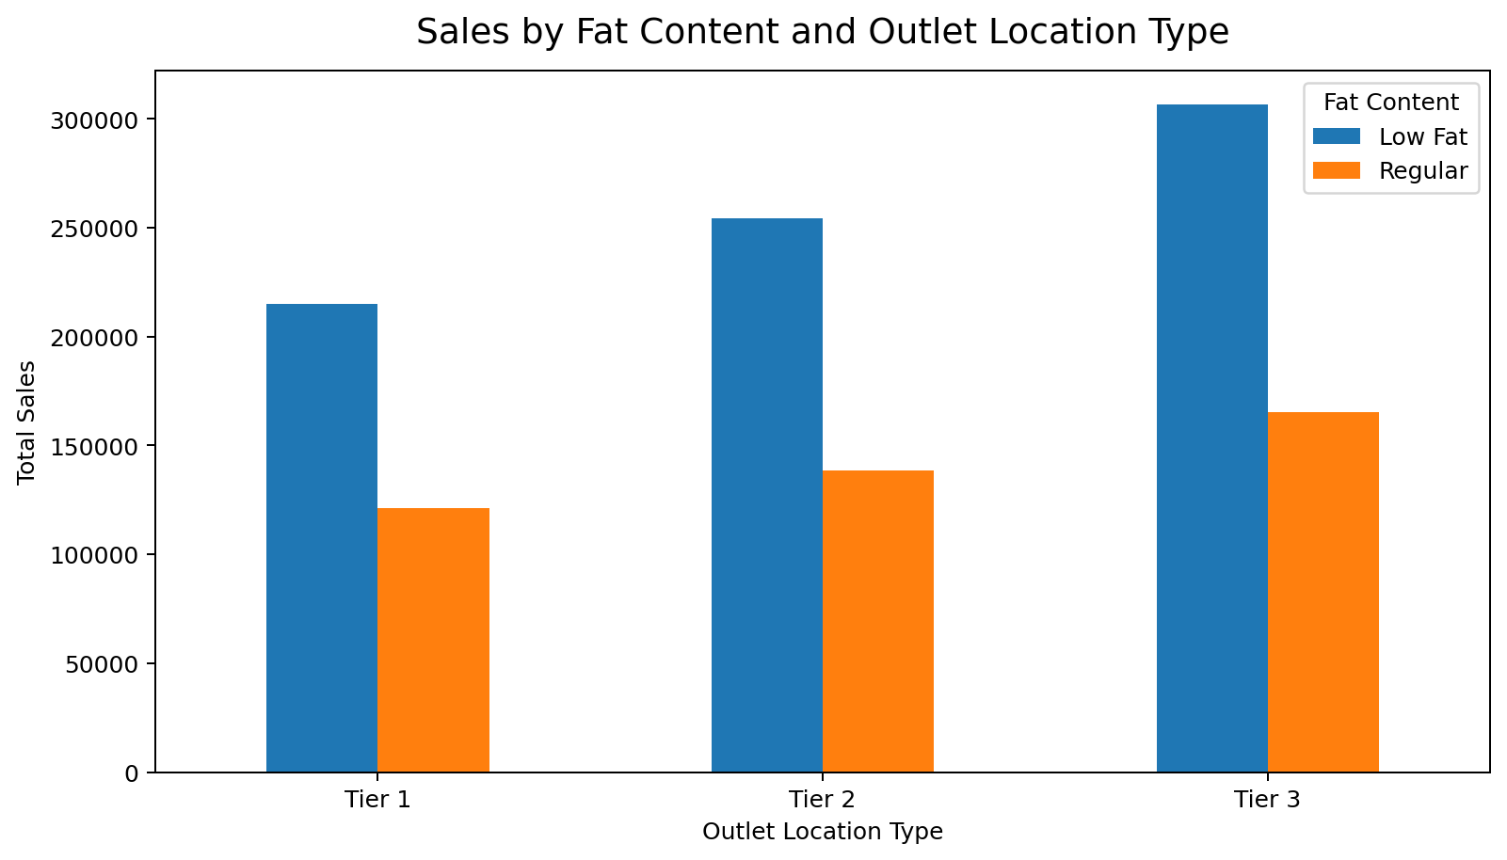
This segmentation compares sales for the fat-content categories across outlet location tiers.

8. Key Insights from the Supplied Dataset
- Overall sales in the supplied dataset total approximately 1,201,681.49, across 8,523 records.
- Fruits and Vegetables is the highest-sales item category, contributing approximately 178,124.08 in sales.
- Tier 3 outlets have the highest total sales among the three location tiers, at approximately 472,133.03.
- Medium outlets contribute the highest total sales among the outlet-size categories, at approximately 507,895.74.
- In the source data, the highest sales total by outlet establishment year occurs for 2018, at approximately 204,522.26.
- The overall average customer rating in the source dataset is approximately 3.97.

Data-quality note: the source dataset contains multiple text variants for Item Fat Content (for example, 'Low Fat', 'low fat', 'LF', 'Regular', and 'reg'). For the documentation summary chart, these variants are normalized into two reporting groups: Low Fat and Regular. This is a documentation-level normalization and should not be interpreted as a claim that the raw PBIX visual displays only two original source labels.

PBIX and Documentation Chart Notes
The Power BI report contains the interactive visuals, KPI cards, slicers, and field selections. The charts embedded in this Word report are static documentation versions generated from the same supplied dataset. This approach keeps the GitHub repository lightweight while preserving the PBIX as the actual interactive deliverable.

9. Conclusion
The BlinkIT Power BI project demonstrates the use of business intelligence techniques to convert grocery sales data into an interactive analytical report. The dashboard combines headline KPIs, product analysis, outlet analysis, trend analysis, segmentation, and interactive slicers. The PBIX file should be opened in Power BI Desktop to explore the full interactive report.

10. Files Included in the GitHub Repository
- BlinkIT_PowerBI_Analysis.pbix – the interactive Power BI report
- BlinkIT_Grocery_Data.xlsx – the source dataset, if redistribution is permitted
- PowerBI_Project_Report.docx – this project documentation
- README.md – repository overview and setup information

